Email system
# Source: AI Source: Provided by: [Data Path: Persons Table -> ID Column: 1, Name_En Column: Motasem Essam] -> From: [ChatGPT] on [1/21/2026]
An email system is the complete infrastructure and software responsible for sending, receiving, storing, and displaying email messages between users over a network (usually the Internet).

📦 What Makes Up an Email System?
# Source: AI Source: Provided by: [Data Path: Persons Table -> ID Column: 1, Name_En Column: Motasem Essam] -> From: [ChatGPT] on [1/21/2026]
An email system involves multiple parts working together:
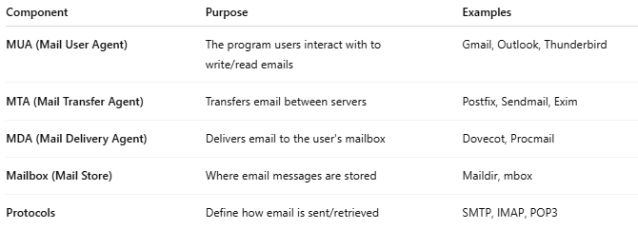
Component | Purpose | Examples
MUA (Mail User Agent) | The program users interact with to write/read emails | Gmail, Outlook, Thunderbird
MTA (Mail Transfer Agent) | Transfers email between servers | Postfix, Sendmail, Exim
MDA (Mail Delivery Agent) | Delivers email to the user's mailbox | Dovecot, Procmail
Mailbox (Mail Store) | Where email messages are stored | Maildir, mbox
Protocols | Define how email is sent/retrieved | SMTP, IMAP, POP3

📤 Full Email Workflow
# Source: AI Source: Provided by: [Data Path: Persons Table -> ID Column: 1, Name_En Column: Motasem Essam] -> From: [ChatGPT] on [1/21/2026]
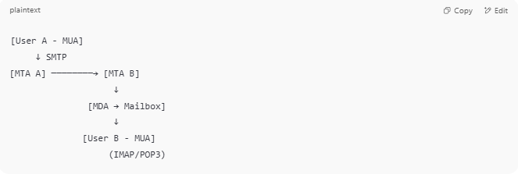

[User A - MUA]
↓ SMTP
[MTA A] ────────→ [MTA B]
↓
[MDA → Mailbox]
↓
[User B - MUA]
(IMAP/POP3)

🧠 Key Concepts
# Source: AI Source: Provided by: [Data Path: Persons Table -> ID Column: 1, Name_En Column: Motasem Essam] -> From: [ChatGPT] on [1/21/2026]
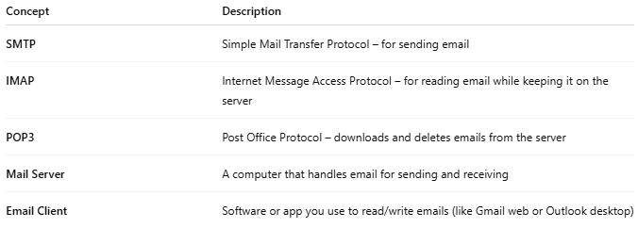

Concept | Description
SMTP | Simple Mail Transfer Protocol – for sending email
IMAP | Internet Message Access Protocol – for reading email while keeping it on the server
POP3 | Post Office Protocol – downloads and deletes emails from the server
Mail Server | A computer that handles email for sending and receiving
Email Client | Software or app you use to read/write emails (like Gmail web or Outlook desktop)

🧪 Email System Examples
# Source: AI Source: Provided by: [Data Path: Persons Table -> ID Column: 1, Name_En Column: Motasem Essam] -> From: [ChatGPT] on [1/21/2026]
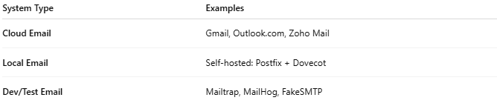

System Type | Examples
Cloud Email | Gmail, Outlook.com, Zoho Mail
Local Email | Self-hosted: Postfix + Dovecot
Dev/Test Email | Mailtrap, MailHog, FakeSMTP

✅ Summary
# Source: AI Source: Provided by: [Data Path: Persons Table -> ID Column: 1, Name_En Column: Motasem Essam] -> From: [ChatGPT] on [1/21/2026]
An email system is a combination of software and protocols that allows you to send, receive, store, and manage email messages across the internet or a private network.
It includes clients (MUAs), servers (MTAs, MDAs), mail storage, and communication protocols (SMTP, IMAP, POP3).

